DFS Using Stack

1. Introduction
Depth First Search (DFS) is a graph traversal algorithm used to explore nodes and edges of a graph. Unlike Breadth First Search (BFS) that uses a queue, DFS uses a stack — meaning it explores as far as possible along each branch before backtracking.
This program implements DFS using a stack (iterative method) on a numerical graph, without using any external libraries or complex imports.

2. Code Explanation
def dfs_stack(graph, start):
visited = []
stack = [start]
print("DFS Traversal Using Stack:")
while stack:
node = stack.pop()
if node not in visited:
print(node, end=" ")
visited.append(node)
for neighbor in graph[node]:
if neighbor not in visited:
stack.append(neighbor)
# Example graph (numerical)
graph = {
0: [1, 2],
1: [3, 4],
2: [5],
3: [],
4: [5],
5: []
}
dfs_stack(graph, 0)

3. Step-by-Step Explanation
a. Defining the Function
def dfs_stack(graph, start):
This function takes two parameters:
- graph → The graph to be traversed (stored as a dictionary)
- start → The node from where DFS begins.
b. Initializing Structures
visited = []
stack = [start]
- visited → keeps track of all visited nodes.
- stack → helps store nodes that need to be explored (LIFO order).
c. DFS Traversal Loop
while stack:
node = stack.pop()
Removes the last added node from the stack. If the node has not been visited yet, it is printed and added to visited.
d. Adding Neighbors
for neighbor in graph[node]:
if neighbor not in visited:
stack.append(neighbor)
All unvisited neighbors of the current node are added to the stack. This ensures DFS goes deep before moving sideways.

4. Example Graph Used
Node | Connected To
0 | 1, 2
1 | 3, 4
2 | 5
3 | —
4 | 5
5 | —

Output

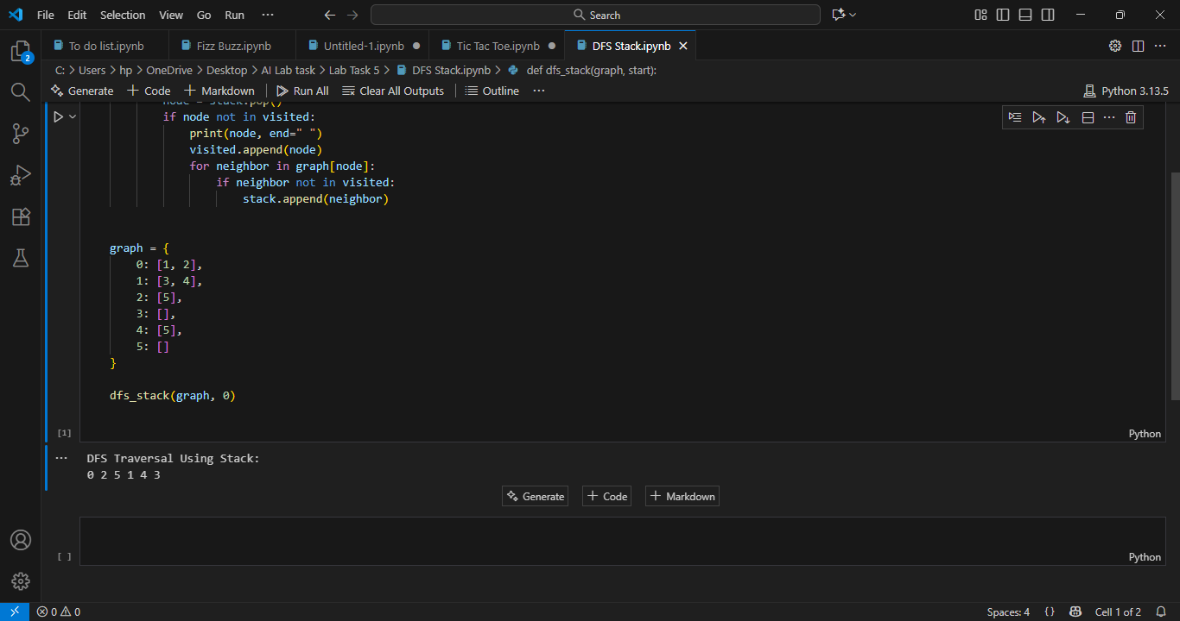

6. Key Python Concepts Used
Concept | Description
List | Used for stack and visited nodes
Loop (while) | Keeps traversal going until all nodes are visited
Condition (if) | Checks if a node is already visited
Dictionary | Represents the graph structure
Function | Organizes the code logically

7. Conclusion
This program demonstrates how DFS works using a stack without recursion. It explores nodes deeply before backtracking, making it efficient for problems like maze solving, pathfinding, and graph connectivity checking.

